Task 4

-- Create a new database (change 'sales_samaple_data' to your desired database name)

CREATE DATABASE 'sales_samaple_data';

-- Connect to the newly created database

\c 'sales_samaple_data;

-- Create the "sales_sample" table with the specified columns

CREATE TABLE sales_sample (

Product_id INTEGER,

Region VARCHAR(50),

Date DATE,

Sales_Amount NUMERIC

);

-- Insert 10 sample records into the "sales_sample" table

INSERT INTO sales_sample (Product_id, Region, Date, Sales_Amount)

VALUES

(1, 'East', '2023-10-01', 1000.00),

(2, 'West', '2023-10-02', 750.50),

(3, 'North', '2023-10-03', 1200.75),

(4, 'South', '2023-10-04', 900.25),

(5, 'Central', '2023-10-05', 1500.00),

(6, 'East', '2023-10-06', 800.00),

(7, 'West', '2023-10-07', 950.75),

(8, 'North', '2023-10-08', 1100.50),

(9, 'South', '2023-10-09', 850.25),

(10, 'Central', '2023-10-10', 1300.00);

Task 4. 3a

SELECT Region, Product_id, SUM(Sales_Amount) AS Total_Sales

FROM sales_sample

GROUP BY Region, Product_id

ORDER BY Region, Product_id;

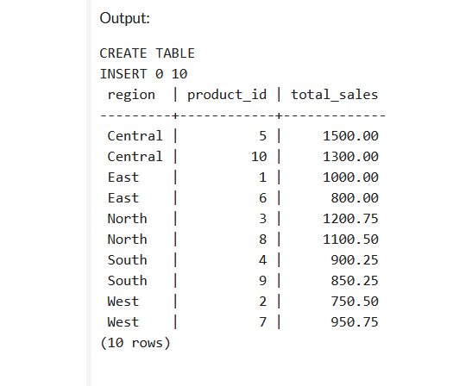

Task 4. 3b

SELECT Region, SUM(Sales_Amount) AS Total_Sales

FROM sales_sample

GROUP BY Region

ORDER BY Region;

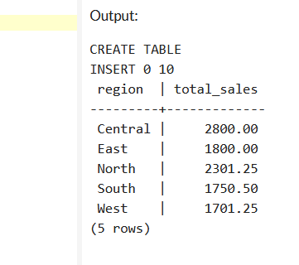

Task 4. 3c

SELECT Region, Product_id, Date, SUM(Sales_Amount) AS Total_Sales

FROM sales_sample

GROUP BY CUBE (Region, Product_id, Date)

ORDER BY Region, Product_id, Date;

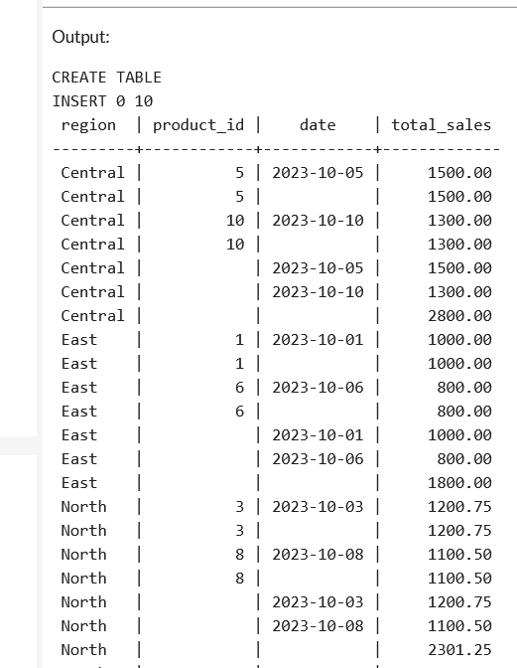

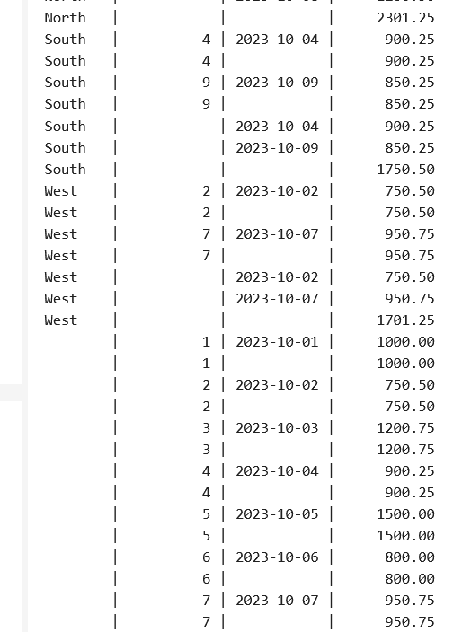

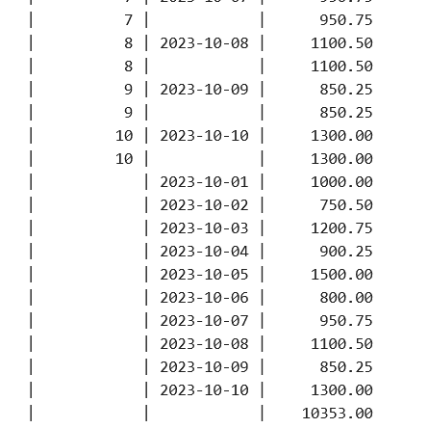

Task 4. 3d

SELECT *

FROM sales_sample

WHERE Region = 'East';

SELECT *

FROM sales_sample

WHERE Date BETWEEN '2023-10-01' AND '2023-10-05';

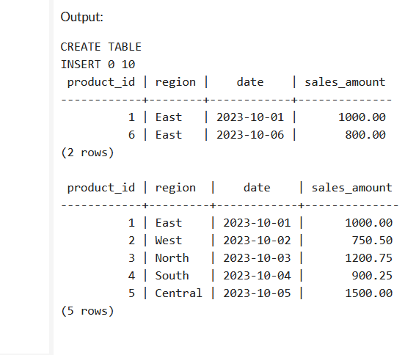

Task 4. 3e

SELECT *

FROM sales_sample

WHERE Product_id = 1

AND Region = 'East'

AND Date BETWEEN '2023-10-01' AND '2023-10-05';

